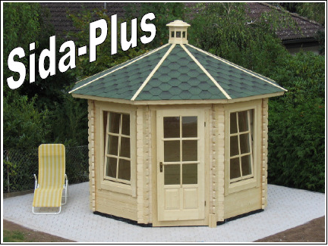
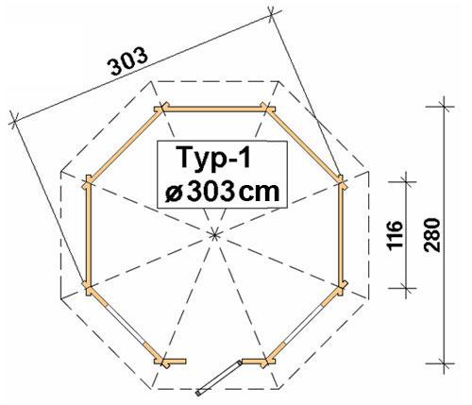
Sida-Plus- Door 3/4 glazed and 2 larger windows

Roof projection: 0.30 m

Consisting of:

Walls: 45 mm double tongue and groove block planks.
Floor: 20 mm tongue and groove with impregnated basic frame.
Roof: 20 mm roof sections.
Doors: 1 glued cartridge door with seal.
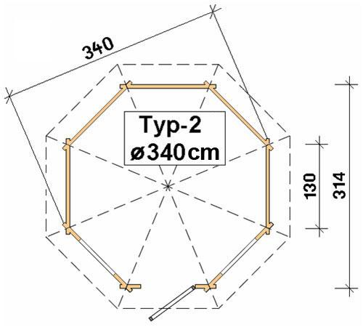
Window: 2 Double-Glazed tilt ‘n’ turn windows with seal and rungs.

Typ1: 1 door 70/193 and 2 windows 70/136 £2,330
1 additional window 70/136 + £145

Typ2: 1 door 90/193 and 2 windows 90/136 £2,600
1 additional window 90/136 + £165

Typ3: 1 door 90/193 and 2 windows 100/136 £3,415
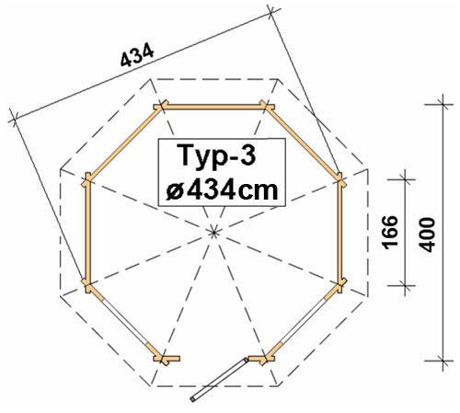
1 additional window 100/136 + £170

Optional Extras:
Typ1 Typ2 Typ3
Furniture: £470 £505 £580
(7 benches, 1 table)
Roof Shingles: Call for Price

